# Chapter 36

## Task 212 – Entity Disambiguation

entity disambiguation

实体库

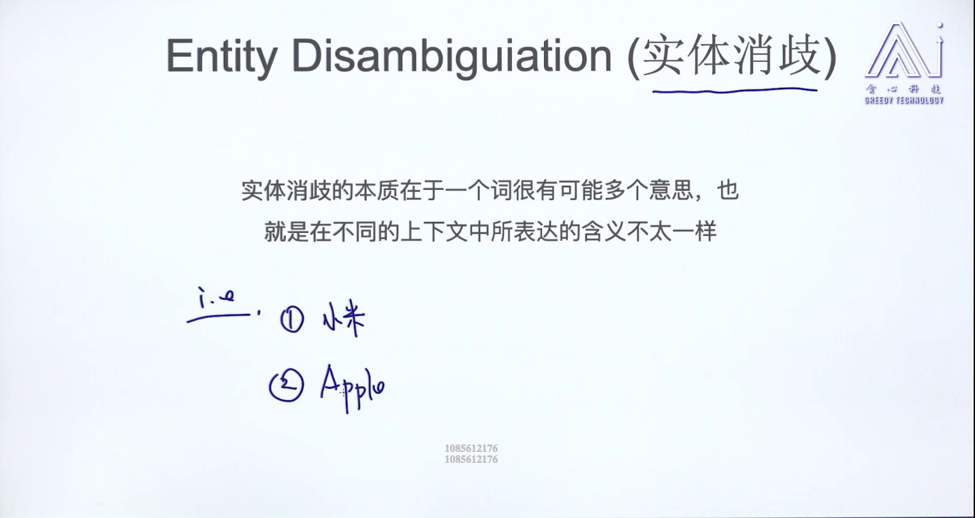

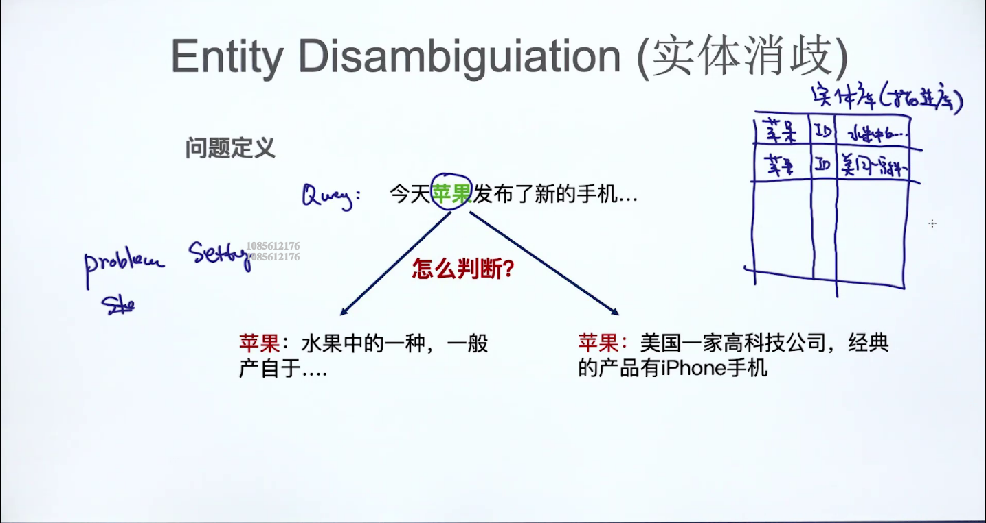

## Task 213 – 实体消歧算法

了解：Tf-idf

Term Frequency — Inverse Document Frequency

**tf-idf** is used to weight words according to how important they are.

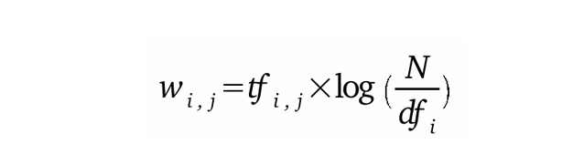

Natural logarithm

了解：词向量

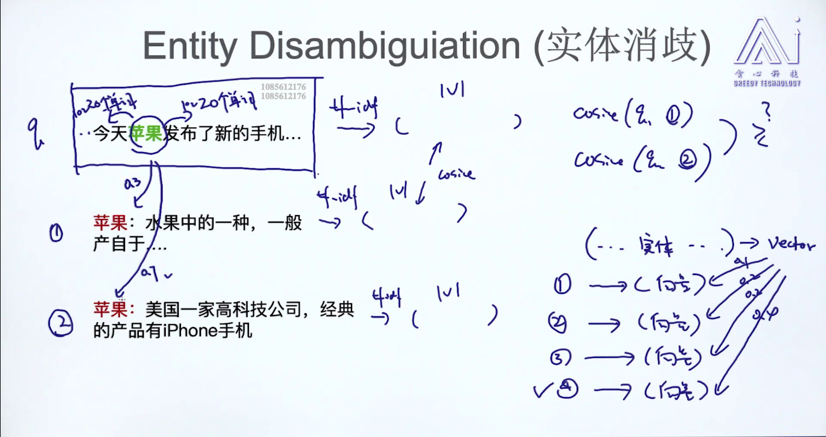

## Task 214 – Entity Resolution (实体统一)

了解：知识图谱

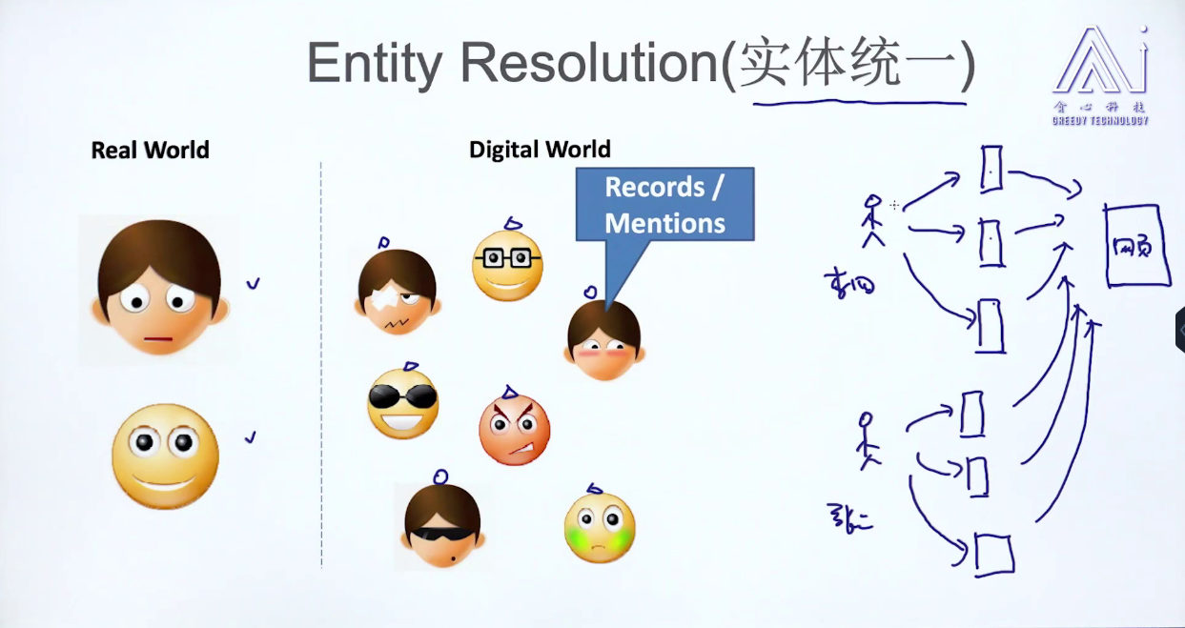

## Task 215 – Entity Resolution算法

了解：编辑距离 （edit distance）

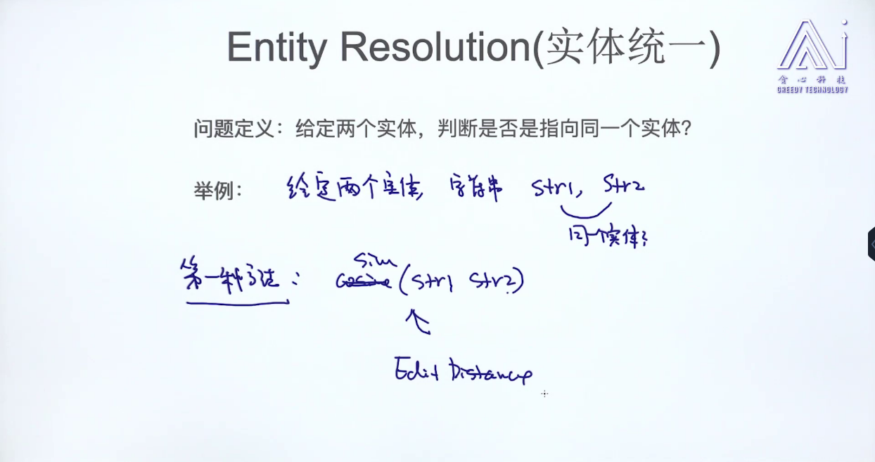

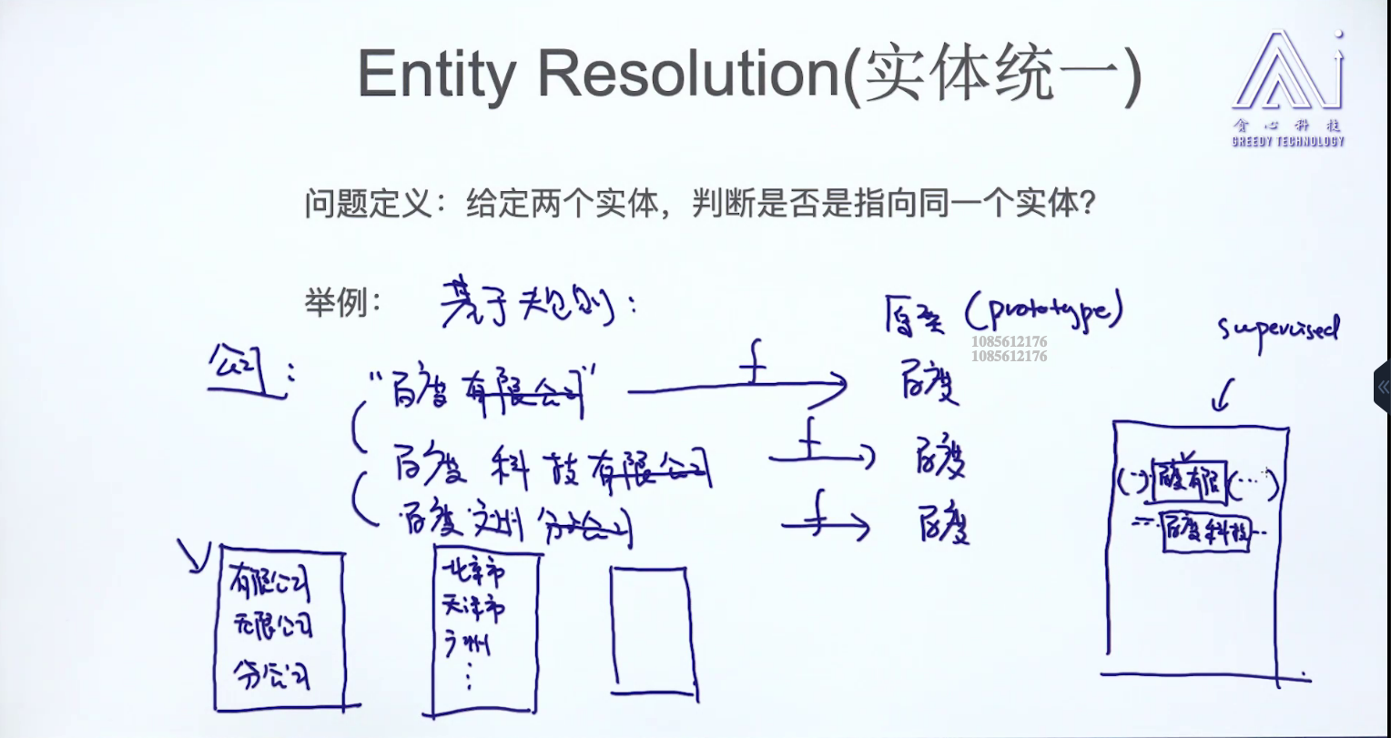

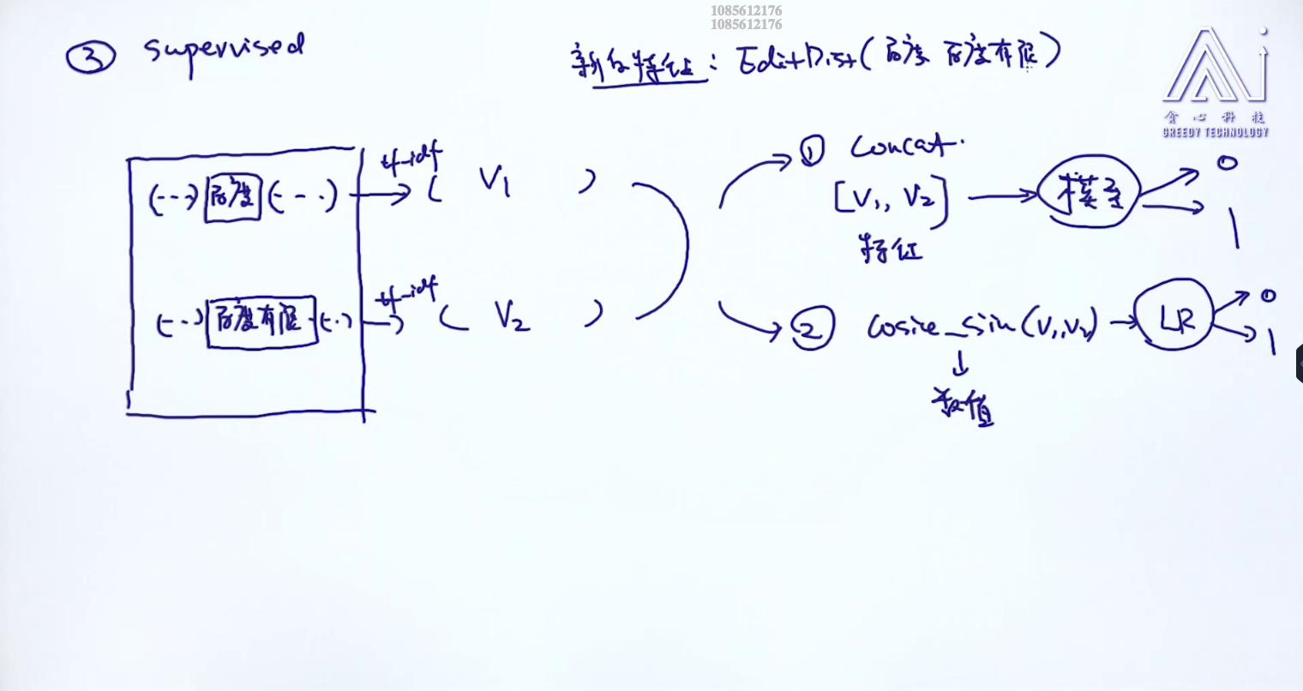

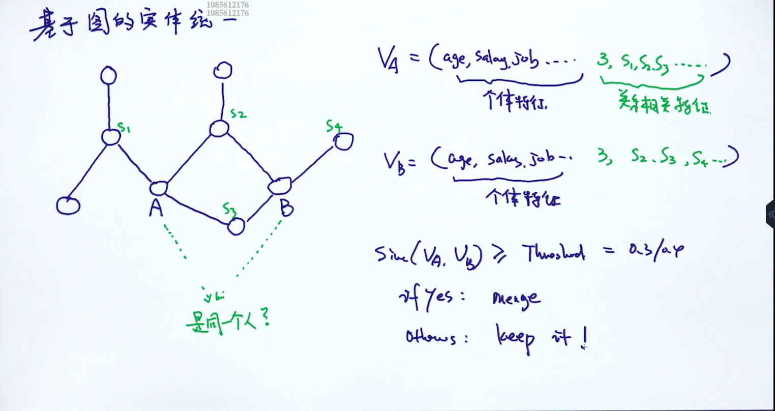

## Task 216: co-reference resolution

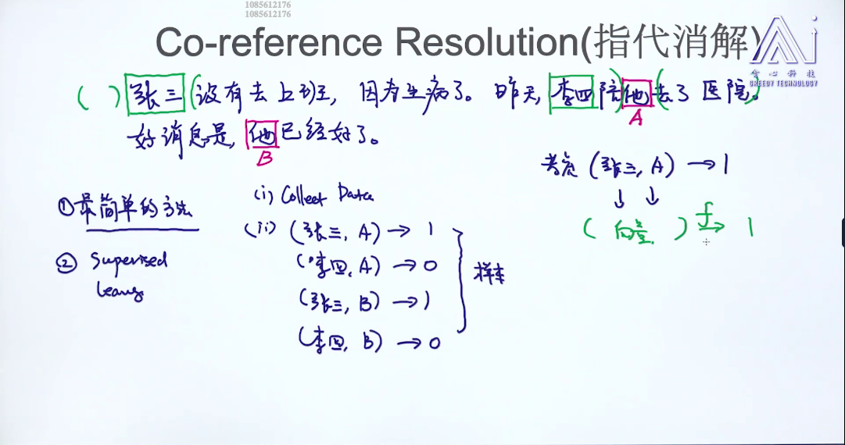

# Chapter 37

## Task 217: 什么是句法分析

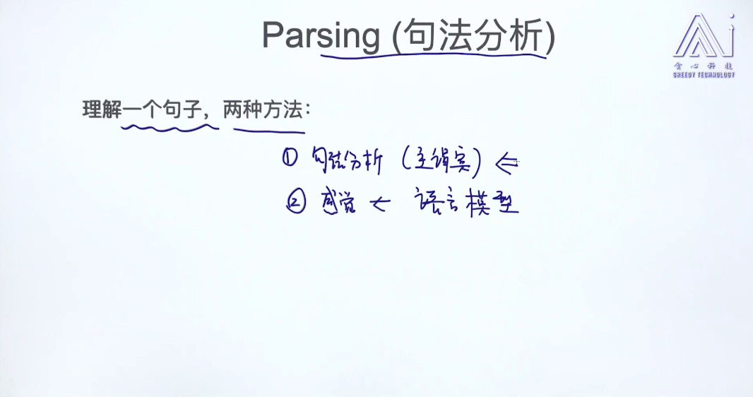

Syntax Tree

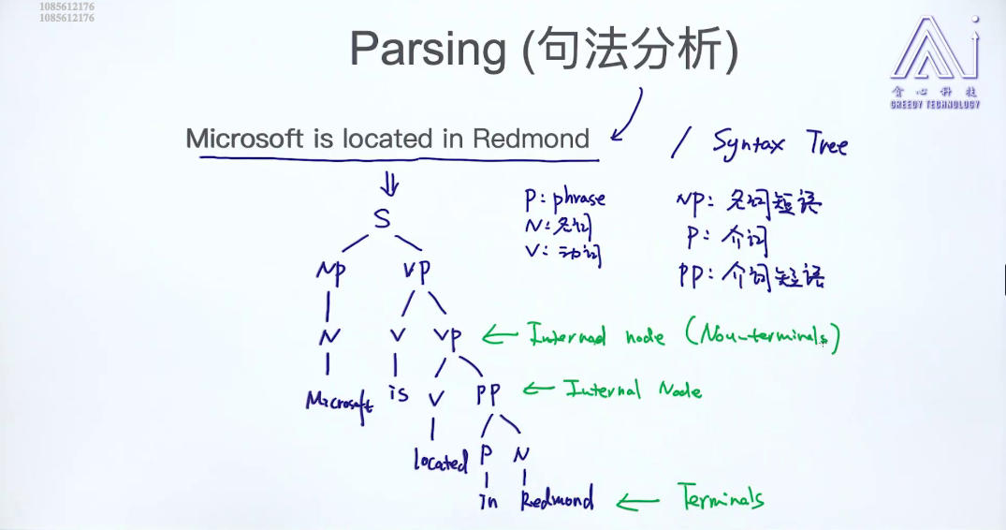

## Task 218: 句法分析的应用

S stands for start

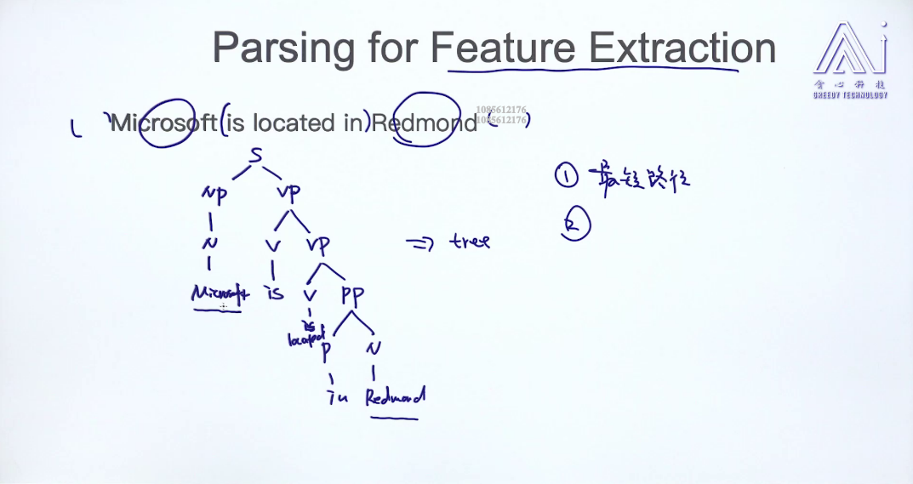

## Task 219: Generate Strings

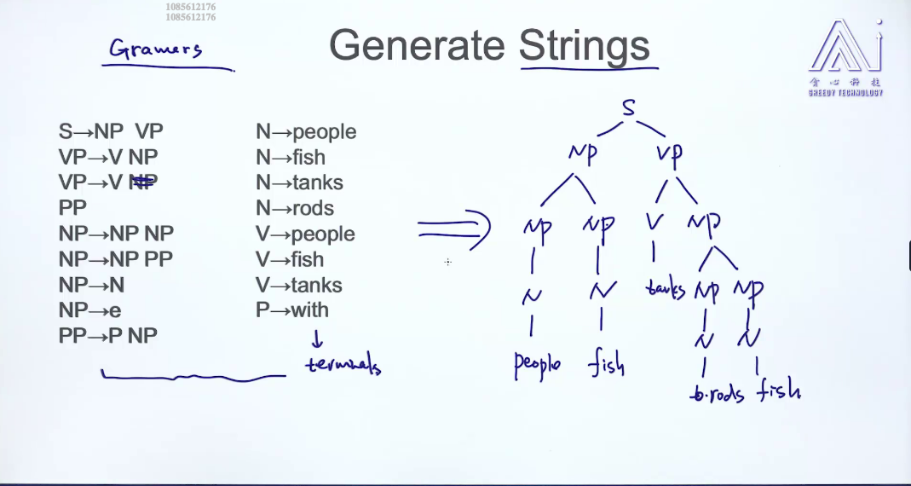

以前需要很多domain knowledge, 从中文的syntax tree 到英文的syntax tree，现在是end to end, 使用seq2seq，直接中文到英文。

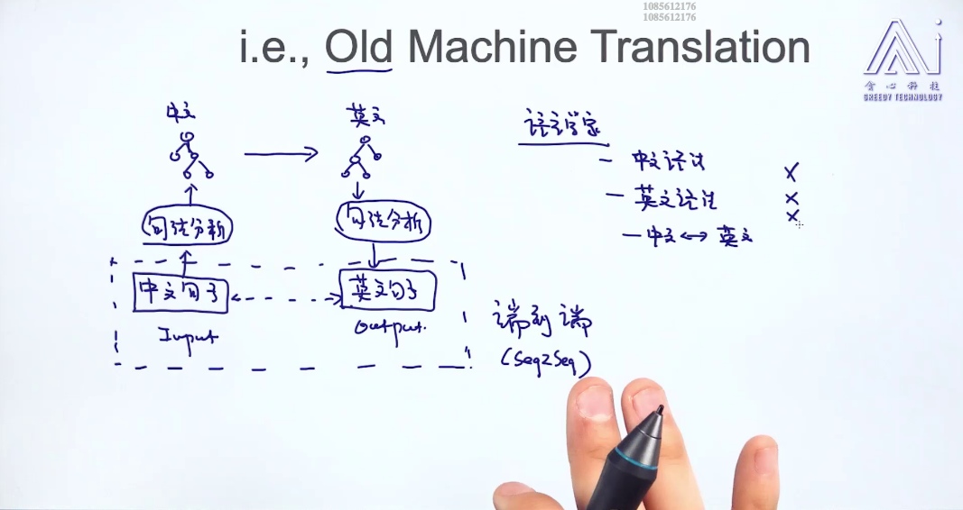

## Task 220: from CFG to PCFG

Cfg: context free grammars

Pcfg: probability context free grammars

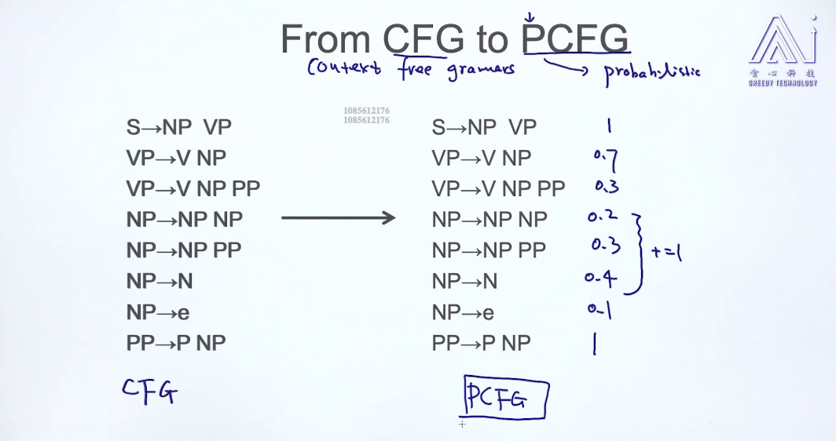

## Task 211: Evaluate Syntax Tree

Get score for every syntax tree, the score is the product of every probability which is from PCFG which we can calculate from training data.

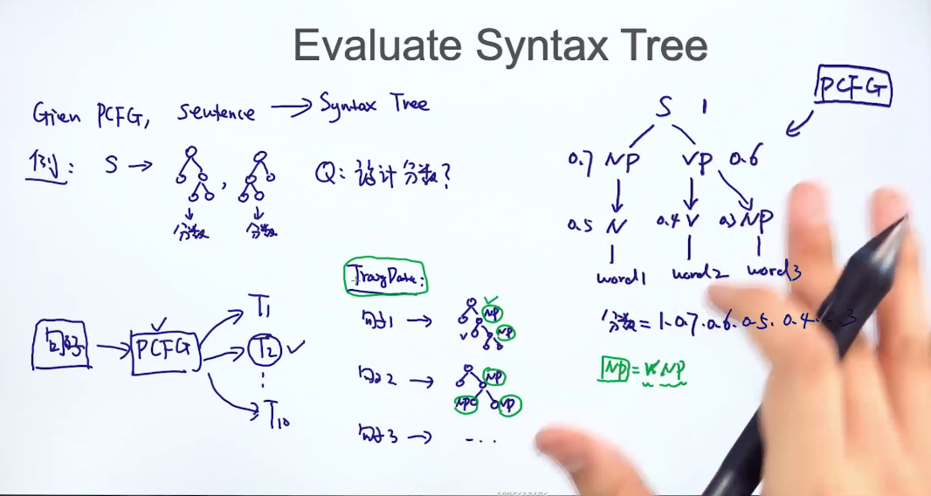

## Task 212: Find the Best Syntax Tree

Enumerate every syntax tree is 指数增长。

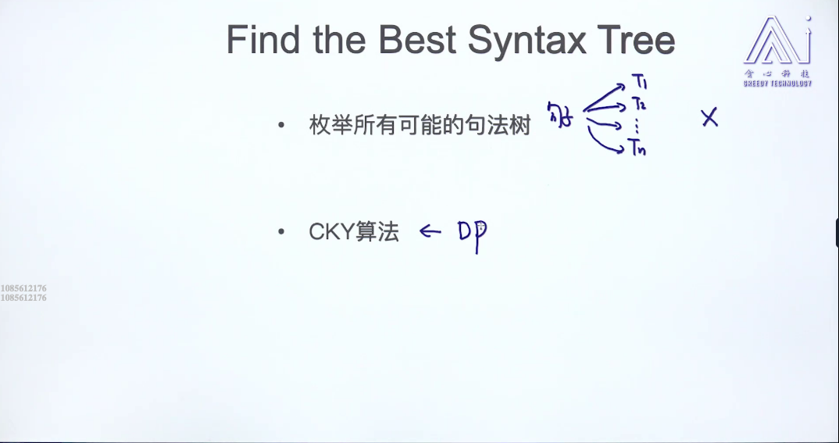

## Task 213: Intuition about CKY Algorithm

CKY algorithm is much used in parsing.

Cky: Vp右边最有只有两个

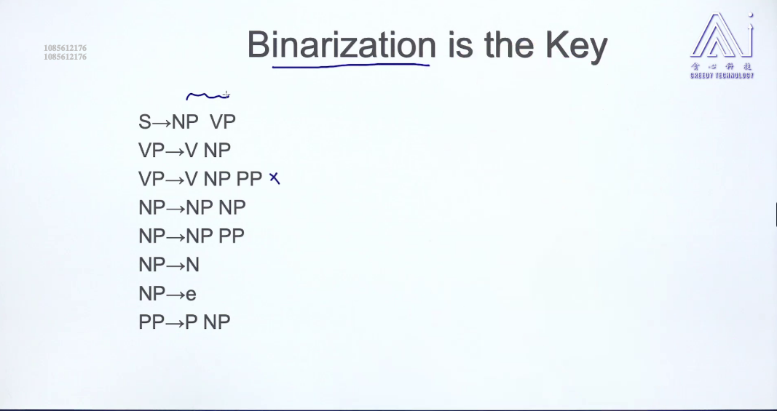

CN右边不能超过2个也 不能只有一个 unary，e stands for empty

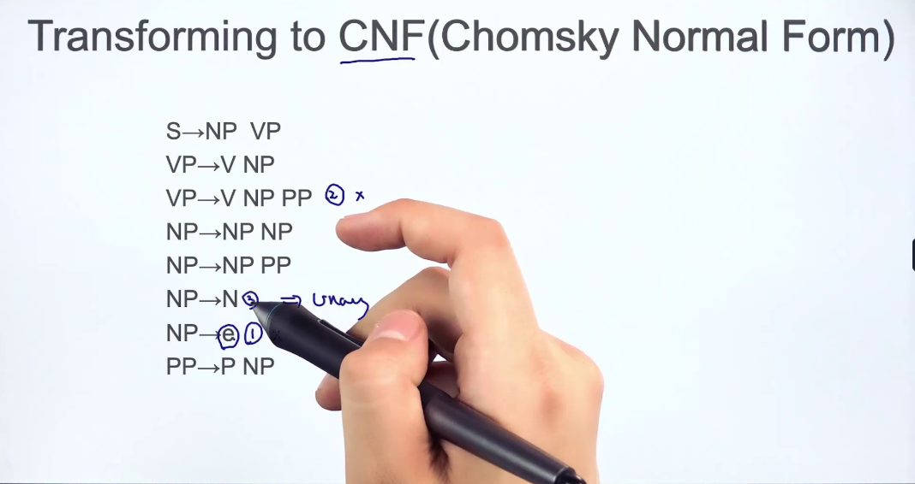

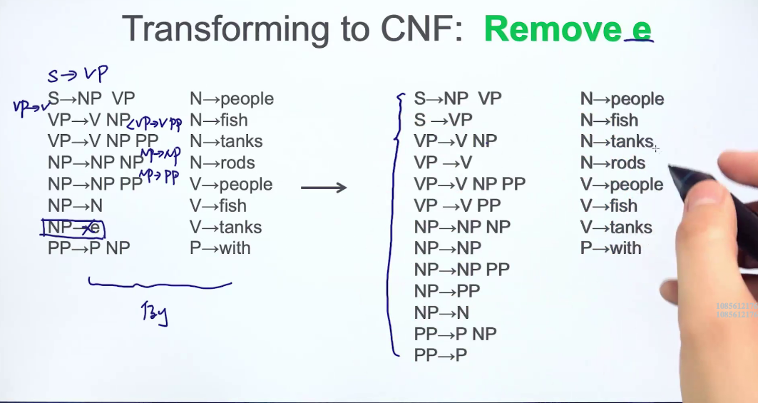

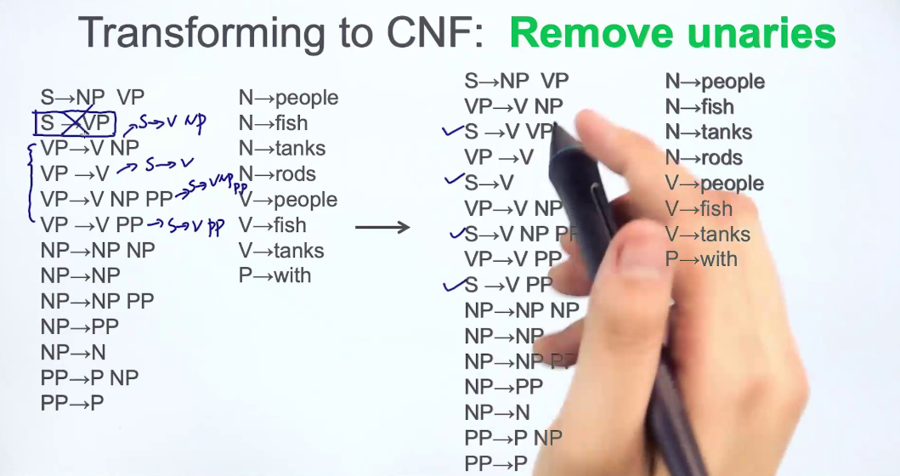

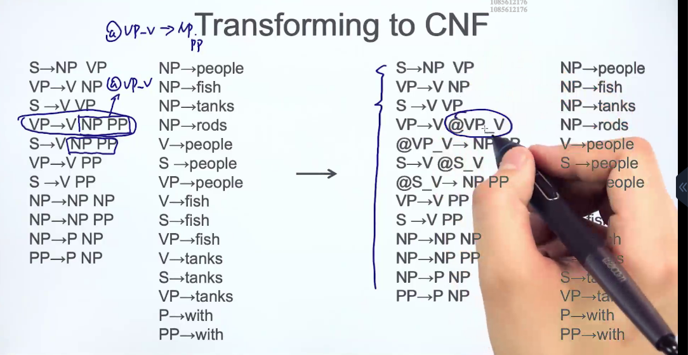

## Task 214: CKY Algorithm

Dynamic program

